Breached Contract Management
User Manual

Table Of Contents

1 What are the Breached Contract Management Features? 1
2 Accessing the Breached Contract Management Functionality 1
3 Using the Manage Breached Contracts Page 1
3.1 Actioning a Single Contract 1
3.2 Actioning Multiple Contracts 2
3.3 Confirmation and Summary 2
3.4 How the Service is Affected 3
3.5 How the Recommended Figures are Calculated 3
3.6 The Payout Fee Equation 3

What are the Breached Contract Management Features?
When a Customer decides to churn or disconnect their lines, Flex receives a notification from the Carrier. The Contract Management features allow users with the Credit Control permission to apply any fees associated with prematurely cancelling a Contract.

Accessing the Breached Contract Management Functionality
Accessing the Breached Contract Management Functionality is achieved by using the Flex Menu.
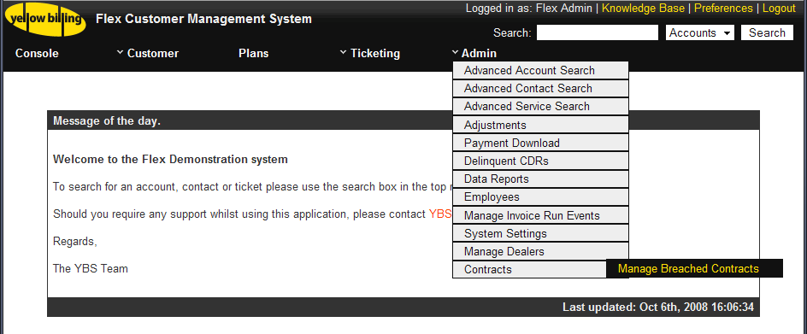
Figure 2-1 Accessing the Contract Management Functionality
The Contract Management Functions are accessed by navigating to the “Admin” menu, then to the “Contracts” submenu, and finally selecting “Manage Breached Contracts”.

Using the Manage Breached Contracts Page
The “Manage Breached Contracts” page is designed to report on all Contracts that have been breached in Flex. From this console, you can apply or waive Contract Exit Fees and Payout figures associated with the Contract.
Each Contract has a recommended Payout and Exit Fee (See Section 8.3). You can choose to take the advice of Flex, or override by modifying the Payout percentage or Exit Fee. If you wish to waive one of the fees, but not the other, simply set the waived fee to 0.
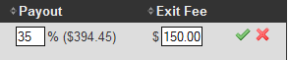  Figure 3-1 Recommended Fees | 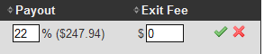  Figure 3-2 Overridden Payout, Waived Exit Fee

Actioning a Single Contract
To action a single Contract, simply click on the green tick () to Apply the fees, or the red cross () to Waive. (NB: Any other Contracts that were selected before this will be deselected)

Actioning Multiple Contracts
It is possible to perform a mass-Apply or Waive. You can either manually select the Contracts to apply, or use the Select All and None buttons for quick selecting.
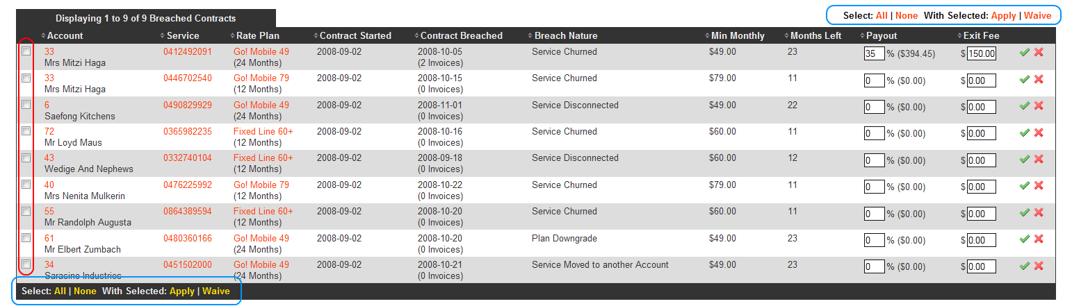
Figure 3-3 The batch Select checkboxes (red) and actions (blue)
Once you have selected the Contracts you wish to action, you can then use the “With Selected Apply/Waive” buttons.

Confirmation and Summary
Once you have clicked the Apply or Waive button, you will be presented with a Confirmation and Summary popup.
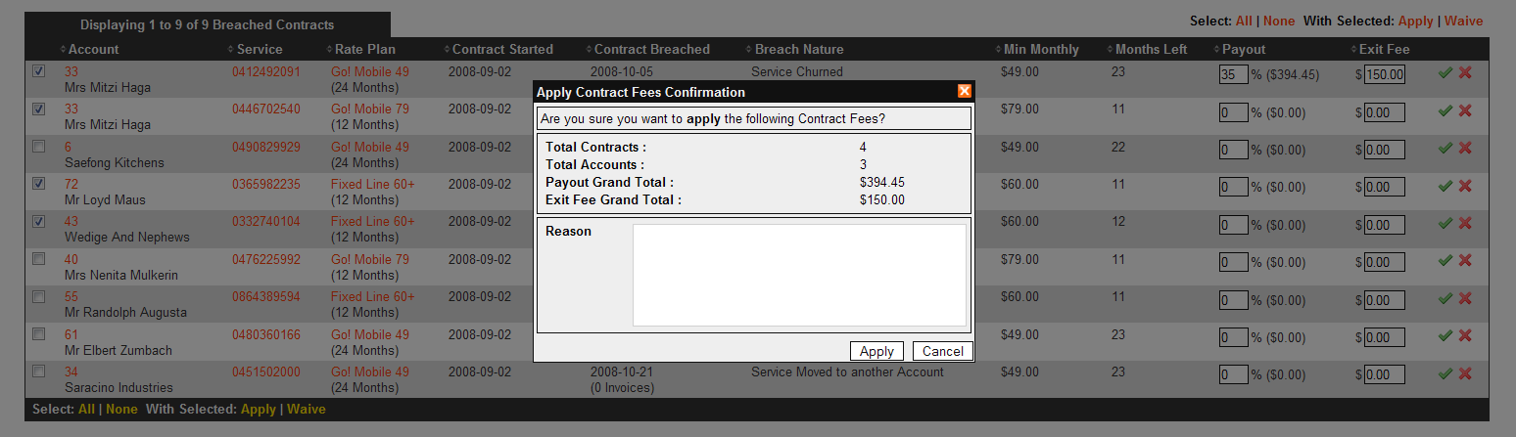
Figure 3-4 Confirming the application of fees to multiple Contracts
The popup summarises the charges to fee Applied or Waived, and also prompts for a Reason. This is optional. If you are satisfied with the figures, click the Apply/Waive button. If you wish to review, you can click the Cancel or Close () button. This is the last opportunity to abort the action.
When you click the Apply/Waive button, you are presented with a Progress popup. This popup also provides a short summary for each Contract, including clickable Account and Service numbers for you to visually confirm that each Service has been affected.
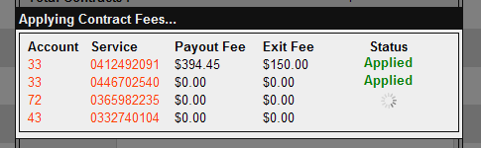 | 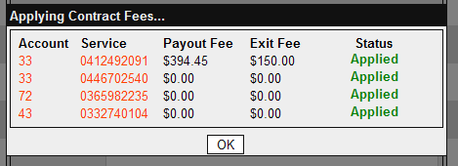
Figure 3-5 Actions in progress | Figure 3-6 All Actions completed
Once the process is complete, you are able to click “OK” to return to the list. In the unlikely event that you receive an Error message, or the Processing () icon appears on a single Contract for an extended period of time, please notify Yellow Billing immediately with details of the Contract(s) you attempted to action.

How the Service is Affected
When a Breached Contract is actioned, the following changes will be apparent on the associated Service:
- Apply Action
  - A System Note will be added detailing the charges. If either of the charges had a value of $0.00, it will appear as “Waived”
  - The appropriate Service Adjustments will appear on the Invoice & Payments page
- Waive Action
  - A System Note will be added detailing the action
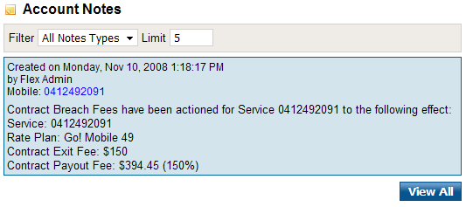 | 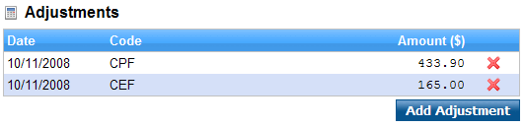
Figure 3-7 System Note detailing the action | Figure 3-8 Adjustments on Invoices & Payments
(NB: The figures shown in the System Note are ex-GST, whereas those shown in the Adjustments list are inc-GST)

How the Recommended Figures are Calculated
The Payout Percentage and Exit Fee figures are defined at Rate Plan creation. This allows each Plan/Contract to have its own recommended values.
There is also a global Flex setting which defines the minimum number of Invoices a Contract must have appeared on before it can receive the fees. The default settings are:
- Contract Payout Fee – 2 Invoices
- Contract Exit Fee – 1 Invoice
These minimum values, and the names and codes of the Adjustments can be changed by contacting Yellow Billing Services.

The Payout Fee Equation
The Payout Fee is calculated using the following equation:
Payout Fee = Min Monthly × Months Left × (Payout Percentage ÷ 100)
For example:
$220.50 = $49.00 × 18 × (25% ÷ 100)
The Payout Fee is always automatically rounded to the nearest cent.

